**TRAFFIC MANAGEMENT**

**SUBMITTED BY:**

**E.Naveenraj**

**S.Sakthivel**

**M.Manimaran**

**M.Sachin**

**P.Sanmugam**

**Abstract:**

* Effective traffic management is a critical component of urban infrastructure, aimed at ensuring safe and efficient movement of people and goods in densely populated areas. In contemporary urban landscapes, the complexities of traffic congestion, environmental concerns, and the increasing demand for transportation necessitate innovative solutions. This abstract provides an overview of modern traffic management strategies, technologies, and challenges.
* The foundation of modern traffic management is the integration of advanced technologies, such as IoT sensors, AI-driven algorithms, and real-time data analytics. These technologies enable the collection of real-time traffic data from various sources, including traffic sensors, cameras, and mobile applications. This data is processed to provide commuters with accurate and up-to-date information, facilitating informed route decisions and promoting sustainable transportation choices.
* Key components of modern traffic management include real-time traffic monitoring systems, responsive traffic signal control, dynamic routing recommendations, incident management, and predictive analytics. These components work in synergy to alleviate traffic congestion, reduce travel times, lower emissions, and enhance road safety.

**The objectives of a traffic management project typically include:**

1. Congestion Reduction: To alleviate traffic congestion in urban areas, making travel more efficient and less time-consuming for commuters.

2. Improved Safety: Enhancing road safety by implementing measures to reduce accidents and minimize the severity of collisions.

3. Traffic Flow Optimization: Ensuring a smooth and consistent flow of traffic to reduce stop-and-go conditions and minimize traffic jams.

4. Reduced Environmental Impact: Minimizing vehicle emissions and fuel consumption by reducing idling and congestion.

5. Public Transportation Integration: Promoting the integration of public transportation systems with road networks to encourage the use of buses, trains, and other mass transit options.

6. Effective Incident Management: Developing strategies for quick response and management of traffic incidents such as accidents, road closures, or construction.

7. Data Collection and Analysis: Gathering and analyzing traffic data to make informed decisions about road improvements and to provide real-time information to commuters.

8. Infrastructure Development: Planning and executing road infrastructure projects, such as road widening, new road construction, and intersection improvements.

9. Technology Integration: Incorporating modern technology like traffic lights synchronization, variable message signs, and intelligent transportation systems to manage traffic effectively.

10. Public Awareness and Education: Educating the public about traffic rules, safety measures, and the benefits of carpooling or using public transportation.

11. Policy and Legislation: Reviewing and implementing traffic-related policies and legislation to ensure safety and compliance with regulations.

12. Emergency Response Planning: Developing and maintaining emergency response plans for handling extreme traffic situations, such as natural disasters or large-scale events.

**Setting up IoT sensors for traffic management involves several key steps:**

1. Sensor Selection: Choose the appropriate sensors for your specific traffic management needs. Common sensor types include cameras, ultrasonic sensors, radar sensors, and inductive loop sensors.

2. Sensor Placement: Install sensors at strategic locations, such as intersections, roadways, pedestrian crosswalks, and parking areas. Ensure they are securely mounted and positioned to capture relevant data effectively.

3. Power Supply: Ensure a stable power source for the sensors. Depending on the location and sensor type, this could involve wired power, battery packs, or even solar panels for sustainability.

4. Connectivity: Establish reliable connectivity for the sensors. This might involve Wi-Fi, cellular, or Low-Power Wide-Area Network (LPWAN) options like LoRa or NB-IoT, depending on the range and data transfer requirements.

5. Data Collection and Transmission: Set up a mechanism for the sensors to collect data, process it, and transmit it to a central hub or cloud platform. Ensure data encryption and security measures are in place to protect sensitive information.

6. Data Processing: Implement data processing and analytics capabilities to make sense of the collected data. This could involve real-time analysis to detect traffic congestion, vehicle counts, speed monitoring, and more.

7. User Interface: Develop a user-friendly interface or dashboard for traffic management personnel to access and interpret the sensor data. This interface should provide real-time information and historical data analysis.

8. Alerts and Notifications: Configure the system to generate alerts and notifications for specific traffic incidents or anomalies, such as accidents, congestion, or road closures. This ensures timely response.

9. Integration: Integrate the traffic management IoT system with other infrastructure, such as traffic lights, variable message signs, and traffic control centers. This allows for coordinated and responsive traffic control.

10. Maintenance and Monitoring: Regularly maintain and monitor the sensors to ensure they are operational. Implement predictive maintenance strategies to prevent downtime.

11. Scalability: Plan for scalability to accommodate future growth and changes in traffic patterns. This includes adding more sensors and expanding the system as needed.

12. Compliance and Regulations: Ensure that the setup complies with local regulations and data privacy laws. This is particularly important when dealing with data collected from public areas.

13. Testing and Optimization: Before deploying the system at scale, conduct thorough testing and optimization to fine-tune the sensors and algorithms for accuracy and reliability.

14. Documentation and Training: Provide documentation and training for personnel responsible for operating and maintaining the IoT traffic management system.

15. Data Storage and Backup: Implement a robust data storage and backup strategy to safeguard the collected data for future analysis and reporting.

**Developing a mobile app for traffic management is a complex project that involves several key steps and considerations:**

1. Define the Purpose: Clearly define the purpose and objectives of your traffic management app. Determine whether it's for real-time traffic monitoring, navigation, incident reporting, or a combination of these functions.

2. User Research: Understand the needs and preferences of your target users, such as commuters, traffic authorities, or city planners. Conduct user research to gather insights.

3. Features and Functionality:

- Real-time Traffic Updates: Integrate real-time data from traffic sensors, cameras, and GPS to provide users with up-to-date traffic conditions.

- Navigation: Implement GPS-based navigation with features like turn-by-turn directions, traffic-based route suggestions, and voice-guided directions.

- Incident Reporting: Allow users to report accidents, road closures, and other incidents. Include photo upload and geolocation tagging.

- Alerts and Notifications: Send push notifications to users about traffic incidents, road closures, or alternative routes.

- Data Analytics: Utilize collected data for historical traffic pattern analysis and reporting.

- Integration with Traffic Infrastructure: Connect with traffic lights, variable message signs, and control centers for a comprehensive traffic management system.

4. Platform Selection: Decide whether to develop the app for Android, iOS, or both (cross-platform development). Choose the development tools and frameworks accordingly.

5. Data Sources: Establish partnerships or access data sources for real-time traffic information, such as traffic sensor networks, GPS providers, and public traffic data APIs.

6. User Interface (UI) and User Experience (UX): Design an intuitive and user-friendly interface. Focus on easy navigation, clear maps, and visualizations of traffic conditions.

7. Backend Development: Build a robust backend to handle data processing, user accounts, notifications, and data storage. Implement server-side logic for incident reporting and data analytics.

8. Security: Implement strong security measures to protect user data and ensure the integrity of traffic information. Use encryption for data transmission and storage.

9. Scalability: Design the app and backend to be scalable to accommodate a growing user base and increasing data volume.

10. Testing: Rigorously test the app for usability, performance, and security. Ensure it functions smoothly on various devices and operating systems.

11. Regulatory Compliance: Ensure compliance with local regulations, data privacy laws, and any specific requirements related to traffic management apps.

12. Feedback and Improvement: Encourage user feedback and regularly update the app to fix bugs, add new features, and enhance the user experience.

13. Marketing and Promotion: Develop a marketing strategy to promote the app to your target audience. Consider partnerships with local authorities or transportation agencies.

14. Maintenance and Support: Provide ongoing maintenance and support to address issues, update the app for new OS versions, and add features as needed.

15. Data Monetization (Optional): Explore opportunities for monetizing the app through advertisements, premium features, or data licensing.

**Integrating Raspberry Pi :**

1. Sensor Integration:

- Connect various traffic sensors (e.g., ultrasonic sensors, cameras, and radar sensors) to the Raspberry Pi via GPIO pins, USB, or other compatible interfaces.

- Utilize Python or other programming languages to develop drivers or scripts for data acquisition from these sensors.

2. Data Processing:

- Use the processing power of the Raspberry Pi to analyze and preprocess the data from connected sensors.

- Implement algorithms for detecting traffic flow, congestion, and incidents.

3. Connectivity:

- Establish network connectivity, typically via Ethernet or Wi-Fi, to enable data transmission.

- Ensure that the Raspberry Pi can communicate with central servers or cloud platforms to send and receive traffic data.

4. Data Storage:

- Store collected data locally on the Raspberry Pi or configure it to upload data to a remote server or cloud storage for long-term storage and analysis.

5. Remote Monitoring:

- Set up remote monitoring capabilities to access the Raspberry Pi and its data remotely. This can be achieved through SSH or VNC (Virtual Network Computing) for remote desktop access.

6. Dashboard and Visualization:

- Create a web-based dashboard or user interface to display real-time traffic data, analytics, and alerts. Use web frameworks like Flask or Django for this purpose.

7. Alerts and Notifications:

- Configure the system to generate alerts and notifications in response to specific traffic incidents or anomalies detected by the Raspberry Pi.

8. Integration with Traffic Infrastructure:

- Connect the Raspberry Pi to other traffic infrastructure components, such as traffic lights, variable message signs, or control centers, to enable coordinated traffic management.

9. Power Supply:

- Ensure a reliable and uninterrupted power supply for the Raspberry Pi, which can involve using uninterruptible power supplies (UPS) or alternative power sources.

10. Data Encryption and Security:

- Implement encryption and security measures to protect sensitive traffic data and ensure the integrity of the system.

11. Scalability:

- Plan for scalability by considering the potential addition of more Raspberry Pi units to cover a wider area or handle increased traffic data.

12. Regulatory Compliance:

- Ensure that the integration complies with local regulations and data privacy laws, particularly when dealing with data collected from public areas.

13. Testing and Maintenance:

- Thoroughly test the system to ensure accuracy and reliability.

- Establish a maintenance plan to address any issues and keep the Raspberry Pi and its components up to date.

**Implementing code for a traffic management system**

1.Data Collection and Sensor Integration:

- If you're using sensors (e.g., cameras, ultrasonic sensors, radar), write code to interface with these sensors. Depending on the sensor type, you may need to use libraries or SDKs provided by the manufacturers or develop your own drivers.

2.Data Processing:

- Implement code to process the data collected from sensors. This can involve real-time data analysis to detect traffic conditions, congestion, or incidents. Use programming languages like Python, C++, or Java for data processing.

3.Connectivity:

- Set up code to establish network connectivity. This could involve configuring Ethernet or Wi-Fi connections, or using cellular data for remote data transmission.

4. Data Transmission:

- Develop code to transmit the processed data to a central server or cloud platform. This may involve using HTTP, MQTT, or other protocols to send data securely.

5.Data Storage:

- Write code to store data locally on the device (if needed) or to upload it to a remote database. Use database management systems like MySQL or MongoDB to store and retrieve data.

6.User Interface and Visualization:

- Create a user interface (UI) for displaying traffic data in real-time. Use web development technologies like HTML, CSS, and JavaScript to build a dashboard. Frameworks like React, Angular, or Vue.js can be useful.

7.Alerts and Notifications:

- Develop code for generating alerts and notifications based on traffic incidents or anomalies detected by the system. Push notification services like Firebase Cloud Messaging (FCM) or Apple Push Notification Service (APNs) can be integrated.

8.Integration with Traffic Infrastructure:

- If your system interacts with traffic infrastructure like traffic lights, write code to communicate with these components. Depending on the infrastructure, this might involve APIs or protocols like Modbus or BACnet.

9.Security:

- Implement security measures in the code to protect data and the system. Use encryption and authentication mechanisms to ensure data integrity and user privacy.

10.Scalability:

- Design the code with scalability in mind, allowing for the addition of more devices and sensors to cover a broader area or handle increased data.

11.Regulatory Compliance:

- Ensure that your code and system comply with local regulations and data privacy laws. Implement access controls and data anonymization when necessary.

12.Testing and Quality Assurance:

- Thoroughly test the code to ensure it functions as intended. Conduct unit testing, integration testing, and user acceptance testing to catch and resolve issues.

13. Maintenance and Updates:

- Establish a maintenance plan to address any issues, apply updates, and continuously improve the system.

**BLOCK DIAGRAM :**

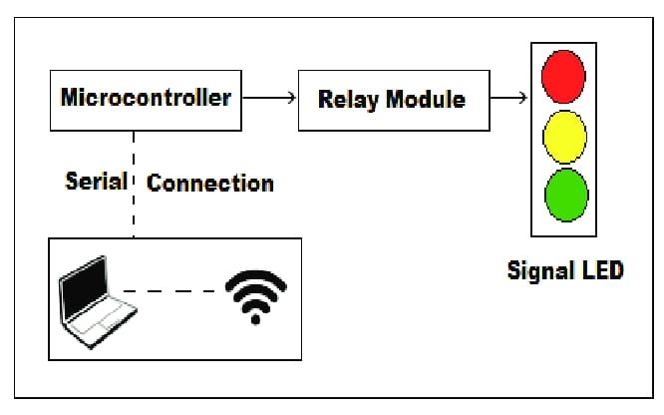

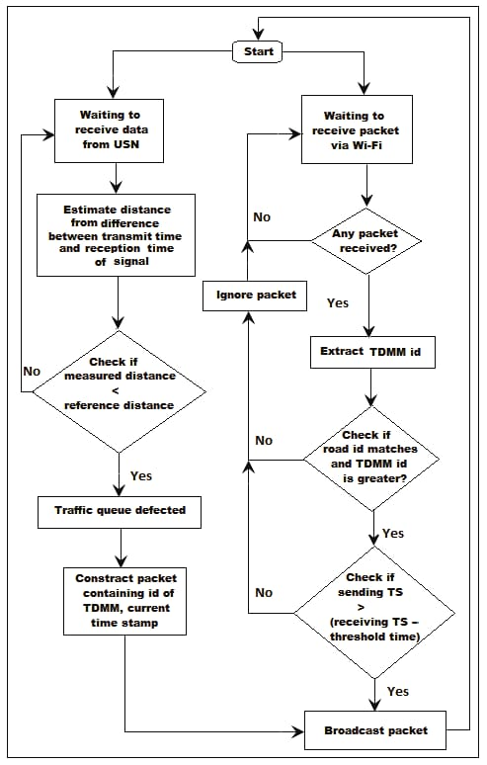

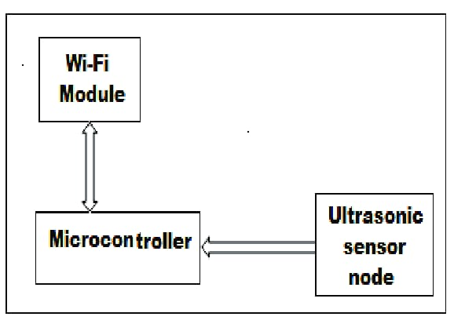

**Schematic Diagram :**

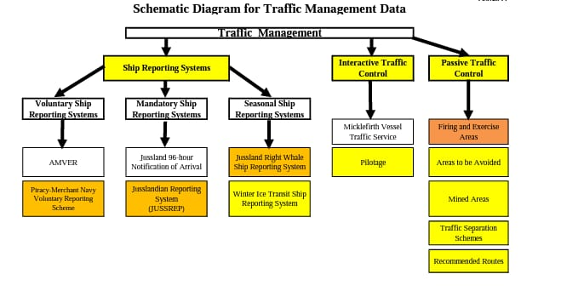

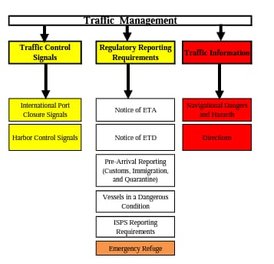

**WOKWI PROGRAM:**

━━━━━━━━━━━━━━━━━━━━━━━━━━━━━━━━━━━━━━━━━━━━━━━━━━━━━━━━━━┓

┃ Raspberry Pi Pico Traffic Light (MicroPython)            ┃

┃                                                          ┃

┃ A traffic light sequence using state machine logic.      ┃

┃ It controls the LEDs to simulate a traffic light,        ┃

┃ cycling through red, yellow, green, and a short yellow.  ┃

┃                                                          ┃

┃ Copyright (c) 2023 Anderson Costa                        ┃

┃ GitHub: github.com/arcostasi                             ┃

┃ License: MIT                                             ┃

┗━━━━━━━━━━━━━━━━━━━━━━━━━━━━━━━━━━━━━━━━━━━━━━━━━━━━━━━━━━┛

"""

import machine

import utime

# Define the LED pins

led_red = machine.Pin(11, machine.Pin.OUT)

led_yellow = machine.Pin(8, machine.Pin.OUT)

led_green = machine.Pin(5, machine.Pin.OUT)

def handle_red_state():

    led_red.value(1)

    led_yellow.value(0)

    led_green.value(0)

def handle_yellow_state():

    led_red.value(0)

    led_yellow.value(1)

    led_green.value(0)

def handle_green_state():

    led_red.value(0)

    led_yellow.value(0)

    led_green.value(1)

def handle_yellow_state_short():

    led_red.value(0)

    led_yellow.value(1)

    led_green.value(0)

# State handlers list

state_handlers = [

    # (state function, time in milliseconds)

    (handle_red_state,            5000),  # Red LED, on for 5 seconds

    (handle_yellow_state,         3000),  # Yellow LED, on for 3 seconds

    (handle_green_state,          5000),  # Green LED, on for 5 seconds

    (handle_yellow_state_short,   2000)   # Short Yellow LED, on for 2 seconds

]

def traffic_light():

    state = 0

    while True:

        # Get the current state tuple (handler function and sleep time)

        current_handler_and_time = state_handlers[state]

        handler_func = current_handler_and_time[0]

        sleep_duration_ms = current_handler_and_time[1]

        # Execute the handler function and sleep for the specified time

        handler_func()

        utime.sleep_ms(sleep_duration_ms)

        # Update the state index

        state = (state + 1) % len(state_handlers)

# Run the traffic light sequence

traffic_light()

**WOKWI OUTPUT:**

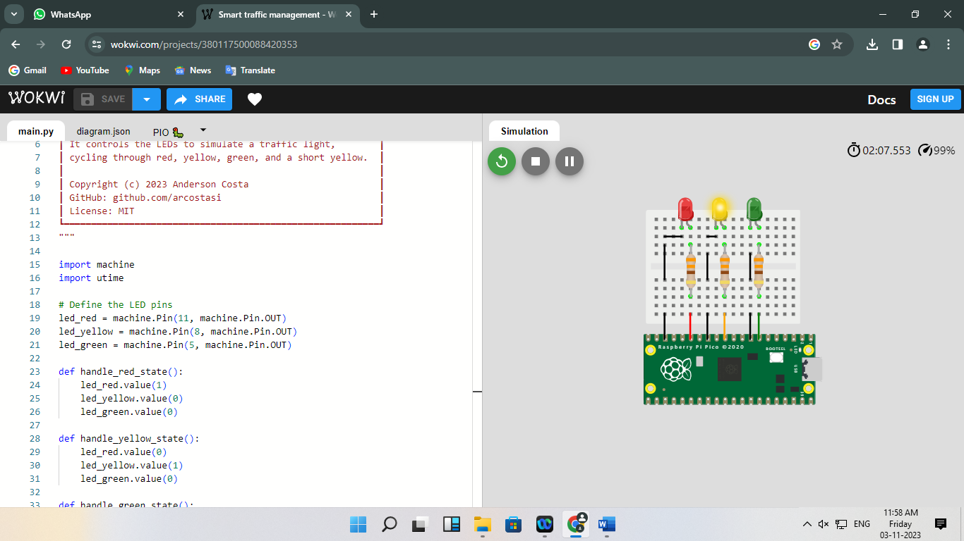

**MOBILE APP:**

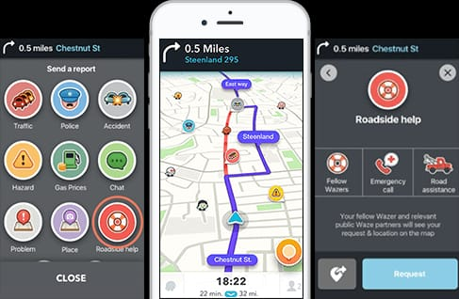

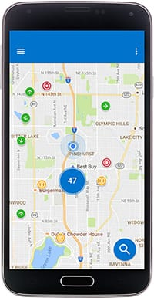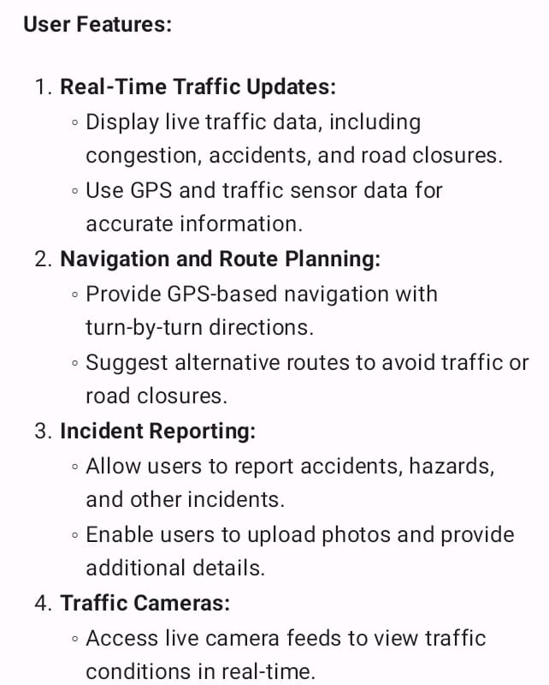

**A real-time traffic monitoring system can be a powerful tool to assist commuters in making optimal route decisions and simultaneously improve traffic flow. Here's how it works:**

1. *Real-Time Data Collection*:

- Traffic monitoring systems gather data from various sources, including sensors, GPS devices, traffic cameras, and user reports. These sources provide real-time information about traffic conditions on the road.

2. *Data Processing*:

- The collected data is processed in real-time to analyze traffic conditions, including congestion, accidents, road closures, and construction zones. Advanced algorithms can predict traffic patterns and congestion areas.

3. *User-Friendly Interfaces*:

- Commuters access this data through various means, including mobile apps, websites, or navigation devices. These platforms provide user-friendly interfaces that display real-time traffic information.

4. *Benefits for Commuters*:

a. *Optimal Route Planning*:

- Commuters can input their destination, and the system provides multiple route options based on current traffic conditions. This allows users to select the quickest and most efficient route, saving time and fuel.

b. *Avoiding Traffic Jams*:

- The system alerts commuters to traffic jams, accidents, or other delays in real-time. Users can then adjust their routes to avoid these problem areas.

c. *Predictive Analysis*:

- Some systems offer predictive analysis, which can estimate future traffic conditions. Commuters can plan their journeys ahead of time, taking into account expected traffic patterns.

d. *Alternative Routes*:

- If a preferred route is congested, the system suggests alternative routes to circumvent the traffic. This minimizes congestion on the primary routes and redistributes traffic.

e. *Incident Reporting*:

- Commuters can contribute to the system by reporting incidents they encounter, such as accidents or road hazards. This information is then used to update the real-time traffic data.

5. *Benefits for Traffic Flow Improvement*:

a. *Traffic Light Control*:

- Traffic management authorities can integrate the system with traffic lights to optimize signal timings. This minimizes stop-and-go traffic, reducing congestion and emissions.

b. *Variable Message Signs (VMS)*:

- Variable message signs along the road can display real-time information to drivers. This encourages drivers to make route decisions that improve traffic flow.

c. *Incident Management*:

- Authorities can respond more efficiently to incidents reported through the system, coordinating emergency services and road closures. This helps clear incidents faster.

d. *Data Analytics*:

- Traffic monitoring systems collect historical data, which can be used to identify traffic patterns and bottlenecks. Authorities can then implement long-term improvements to road infrastructure.

6. *Feedback Loop*:

- Commuters using the system create a feedback loop that continuously enhances the accuracy of the data and the effectiveness of the route recommendations.